**HEAVY DUTY EXHAUST FANS:**

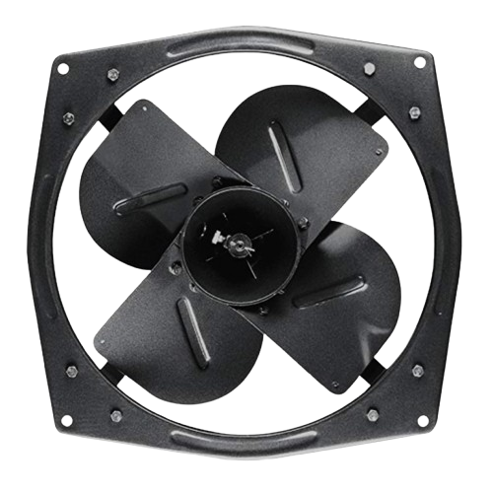

**Price: 12,000.00**

The Heavy Duty Exhaust Fan is a robust and powerful ventilation solution, designed to efficiently remove stale air, moisture, and pollutants from industrial, commercial, and residential spaces. With its durable construction and high-torque motor, this fan delivers exceptional airflow capacity, making it ideal for factories, warehouses, kitchens, and bathrooms. Its corrosion-resistant coating and weatherproof design ensure reliable performance in harsh environments, while its easy installation and low maintenance requirements make it a practical choice for heavy-duty ventilation needs.

**Key features of heavy duty exhaust fans include:**

* **High Airflow Capacity:** Designed to move large volumes of air quickly.
* **Durable Construction:** Built with robust materials for long-lasting performance.
* **Powerful Motor:** Offers strong performance for effective ventilation.
* **Corrosion-Resistant:** Ideal for humid or harsh environments.
* **Energy Efficient:** Consumes less power while providing optimal airflow.
* **Quiet Operation:** Minimizes noise while ensuring efficient ventilation.
* **Versatile Application:** Suitable for industrial, commercial, and large residential spaces.Top of FormBottom of Form